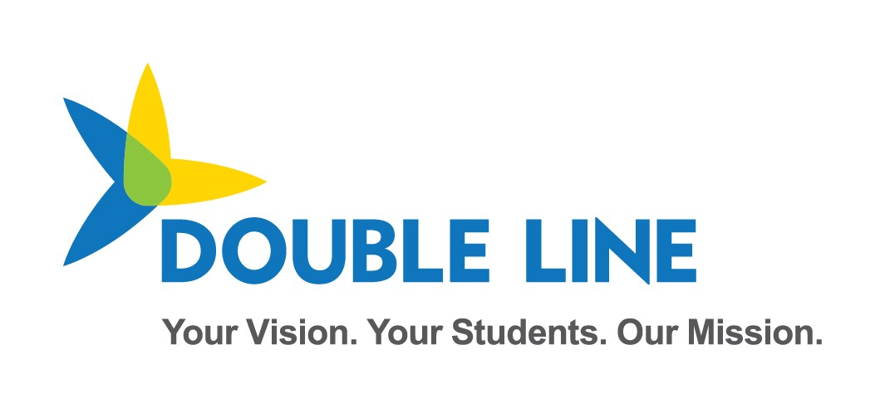

Ed-Fi ODS API Overview for SIS Vendor and District

School Year 2023-2024

Minnesota Department of Education & Minnesota IT Services

Automated Student Data Collection System

Revision date: 3/1/2023

Contents

Change Log 4

Overview 1

MN Sandbox Certification Testing 1

Test Sandbox Environment URLs 1

Sandbox Admin Website 1

Swagger UI 2

Sandbox Base and OAuth URLs 2

ODS/API oauth URL 3

Sandbox Environment Helpful Tips 3

Identifiers: Schools vs. Buildings 5

2023-2024 Data Requirements and API Resources 5

API Documentation 5

Example 5

Mapping Documentation 6

Education Organization Id usage by Resource 6

API Resources and Certification Scenarios 7

Read-Only API endpoints 8

Resource: LocalEducationAgencies 8

Resource: Schools 8

Resource: Post-Secondary Institutions 8

Resource: Course (State Level Only) 8

Resource: Staff 9

Resource: Program 9

Ed-Fi Model Dependency Graphs 2

MARSS collection 2

MCCC collection 3

Early Education Enrollment and Parent collection 4

Staging Environment Load and Quality Check 5

Ed-Fi / MARSS Identities API Integration Test 5

Create Student ID Test 1 6

Create Student ID Test 2 6

Ed-Fi / MARSS Student Record Validation Test 7

Student Validation Process Overview 7

Validate Student ID Test 1 8

Validate Student ID Test 2 8

# Change Log

|  |  |  |
| --- | --- | --- |
| **Version** | **Date** | **Description of Changes** |
| v1.0 | 03/01/2023 | Initial Version for SY23-24 Collection. Replacing many sections with more current references within the GitHub documentation. |

# Overview

Student Information Systems vendors integrating with the Minnesota Department of Education's (MDE) Ed-Fi Automated Student Data Collection system are required to pass 2 levels of testing prior to being granted a district's API key and secret to the production environment.

First, vendors are required to demonstrate their ability to submit specific API resources and elements encompassed within the various MDE Data collection requirements. This first phase is executed in the MNIT Ed-Fi Test Sandbox environment.

Important notes about the Sandbox environment:

* The Test Sandbox environment does not include integration with the Identities API endpoint, meaning student identity is not validated on student records posted to a Sandbox.
* API profiles are not enforced in the Test Sandbox environment, however you may be required to demonstrate appropriate implementation of API profile use in your API transactions.

When all scenarios are verified in the Sandbox testing environment, the SIS vendor is granted access to the Staging Environment. Vendors must perform a test load of their district's real student demographic data in the Staging environment. During this test, Student IDs are validated against the Ed-Fi Identities Service to ensure valid ids are being inserted to the Ed-Fi ODS. MARSS comparison checks and additional data quality verifications are executed in the Staging Environment.

Once the Staging data reaches a satisfactory level of quality as determined by MDE, MNIT, and the District, MNIT will enable the vendor to obtain a key and secret for the production environment.

This document includes the Certification Requirements for both the scenario-based sandbox testing and staging environment data loading.

*Note: many URLs in this document will not be active at first, and thus marked with:*

Not currently active

*Please note that these URLs are also subject to change upon actual Ed-Fi implementation for the 2023-2024 school year.*

# MN Sandbox Certification Testing

When certification begins, vendors will be required to generate a key and secret to a sandbox ODS/API with no sample data pre-loaded. This ODS will contain the Minnesota Education School and District records synchronized with MDE-ORG, MN specific descriptors, District Programs, and the State Course Catalog and Staff records required for the MCCC data collection. When submitting data for each of the Certification scenarios, we ask that you use a district you have access to, and schools within that district.

## Test Sandbox Environment URLs

### Sandbox Admin Website

<https://test.edfi5.education.mn.gov/sb24/admin>

As part of Sandbox certification, you will need access to the [Sandbox Admin Site](https://test.edfi5.education.mn.gov/sb24/admin). To request an account, [contact MDE by email](mailto:EdFiProjectSupportMNIT.MDE@state.mn.us). In the Sandbox Admin Site, you will be able to create ODS instances to use for development and testing of your integrations. ([The Ed-Fi TechDocs](https://techdocs.ed-fi.org/display/ODSAPI31/Using+the+Sandbox+Administration+Portal) have more detailed instructions on setting up sandboxes.)

### Swagger UI

<https://test.edfi5.education.mn.gov/sb24/swagger/>

We continue to use the [Swagger UI tool](https://swagger.io/tools/swagger-ui/) to visualize and interact with the ODS API. Developers can access this [UI for MDE's Sandbox](https://test.edfi5.education.mn.gov/sb24/swagger/) to test-drive Create, Read, Update, and Delete (CRUD) actions before building integrations as necessary.

*Please note:* All MN Specific resources can be found under the Profiles for each School Year:

* Minnesota-Twenty-**Two**-Twenty-**Three**-SISVendor-Profile – For Data submitted to the School Year 2022-**2023** ODS
* Minnesota-Twenty-**Three**-Twenty-**Four**-SISVendor-Profile – For Data submitted to the School Year 2023-**2024** ODS

*Note: The Identities Section is provided as documentation only – and is not functional in the Sandbox environment.*

### Sandbox Base and OAuth URLs

Developers can further test their code integrations at the URLs in this section.

* The base URL for the ODS/API is: https://test.edfi5.education.mn.gov/sb24/api/
* The Data Management URL is: https://test.edfi5.education.mn.gov/sb24/api/data/v3

Please note details below on how the URL changes for addressing extension vs core resources.

#### Extensions

The URL for addressing MN extension resources should include ‘mn’ after v3. For example, when addressing studentSection504PlanProgramAssociations, a Minnesota Dept of Education extension entity, the URL is:

…/api/data/v3/**MN**/studentSection504PlanProgramAssociations

#### Core

The URL for addressing core resources should include ‘ed-fi’ after v3. For example, when addressing StudentSchoolAssociation, a core ed-fi entity, the URL is:

…/api/data/v3/**ed-fi**/StudentSchoolAssociation

**Important Note**: the school year must be included after “/v3/” and before the core/extension namespace in QA, Stage and Production, **but not in Sandbox.**

For example:

…/api/data/v3/**2023**/ed-fi/StudentSchoolAssociation

…/api/data/v3/**2023**/MN/studentSection504PlanProgramAssociations

### ODS/API oauth URL

[https://test.edfi5.education.mn.gov/sb24/api/oauth](https://test.edfi5.education.mn.gov/api/oauth)

Authentication in Ed-Fi Suite 3 ODS/API uses two-legged OAuth 2.0 Client Credentials Grant Flow. More information and sample API calls are located in [the Ed-Fi tech docs.](https://techdocs.ed-fi.org/display/ODSAPIS3V520/Authorization)

## Sandbox Environment Helpful Tips

* In the staging and production environments, SIS vendor API keys will be associated with a claim set limiting access to only the API resources included in this document. This claim set has been enabled in the Sandbox environment. When you access a resource not included in the claim set, you will receive the following message in the response "Access to the resource could not be authorized. Are you missing a claim?”
* A SIS Vendor profile has been created limiting access to specific properties on each of the resources required in each School Year. Profiles are tied to your key and secret and auto-enabled in Staging and Production – meaning you will not have to include the profile in the “accept” or “content-type” headers of the request for the profile to take effect.
* When creating a sandbox, you have the option of including a set of sample data in the sandbox. The sample data used is associated with St. Paul Public School District (LocalEducationAgencyId = 10625000). When you do not select the option to include sample data, your sandbox database will be loaded with an essentially empty ODS except that it will include MN Schools and Districts, and other preliminary seed data such as: the Descriptors that MDE has customized for this implementation, State Course Codes and District Programs.
* The actual certification test will be conducted in a “minimal” sandbox with no sample data loaded and you will reference your own data in the Scenarios, relating elements to MDE Schools, Districts and Descriptors as needed.
* The *Sandbox* Environment *ignores* the School Year included in the API base URL. Remember that when prepping for submissions to *Staging* and *Production*, you need to include the year, i.e. “2024”.
* The School Ids and District Ids used for the ODS/API resources are the MN State Education Organization IDs. See [this section in the GitHub documentation](https://github.com/mn-mde-edfi/MDE-EdFi-Documentation/blob/master/sis_test_plan_b_cert_testing.md#minnesota-district-and-school-ids) for details.
* MN custom descriptor codes have been loaded under the namespace "uri://education.mn.gov/”
* StaffUniqueId will be loaded using the FFN in the Educator Licensing System.
* Post-Secondary Institution IDs will be pre-loaded by MDE; these college identifiers will come from the MDE-ORG system.
* All Descriptor references require namespaces, and do not rely on the concept of a default operational context. Descriptor references must be formatted as follows: uri://[organization indicator]/[name of descriptor]#[code value] For example: **uri://education.mn.gov/ProgramTypeDescriptor#Special Education.**
  + This can be seen when updating a studentSchoolAssociation record. For example, within the MN extension part of the record (shown below), the code value for membershipAttendanceUnitDescriptor is not merely "Days", but "MembershipAttendanceUnitDescriptor#Days":

"_ext": {

"MN": {

"homeboundServiceIndicator": true,

"specialPupilIndicator": true,

"residentLocalEducationAgencyReference": {

"localEducationAgencyId": 10625000

},

"membership": {

"membershipAttendanceUnitDescriptor": "uri://education.mn.gov/MembershipAttendanceUnitDescriptor#Days",

"attendance": 180,

"membership": 180,

"percentEnrolled": 100

},

"transportation": {

"transportationCategoryDescriptor": "uri://education.mn.gov/TransportationCategoryDescriptor#01",

"transportingLocalEducationAgencyReference": {

"localEducationAgencyId": 10625000

}

}

}

}

# 2023-2024 Data Requirements and API Resources

## API Documentation

For each of the resources described in this document, the elements/properties required are included and browseable in the Sandbox Swagger UI (aka "Swagger") under the current profile.

### Example

For example, to view required resource properties for **studentSchoolAssociation**, open the "POST" action in Swagger:

POST /ed-fi/studentSchoolAssociations Creates or updates resources based on the natural key values of the supplied resource.

* *Note:* "ed-fi" in the path above indicates that this is a core resource.

Properties in a **studentSchoolAssociation** can be viewed as an [example/template JSON object](https://github.com/mn-mde-edfi/MDE-EdFi-Documentation/blob/master/data/example_template_studentSchoolAssociation.json) by selecting **"Example Value"**: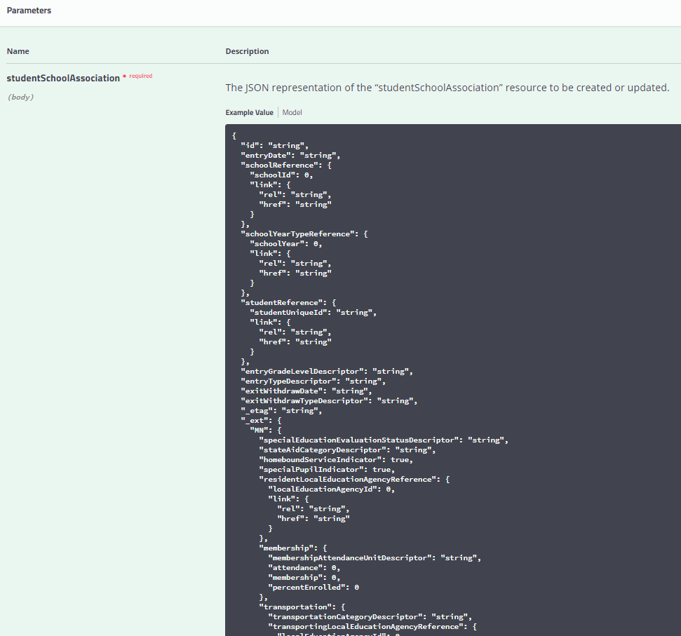

Definitions and Data Types in the **studentSchoolAssociation** can be viewed by selecting **“Model”** just to the right of the "Example Value" option. Required components are marked with a red *. Often, the actual data posting for an individual record can be much less than what is in the model, as demonstrated in the example record linked above.

## Mapping Documentation

For context around how each MDE collection maps to the Ed-Fi Data Standard, please view the Mapping Matrix documents published by MDE.

Each school year's Data Mapping Matrix spreadsheet includes the mappings between MDE elements and Ed-Fi core and extension entities and elements, in the **Data Elements** tab. Additionally, the Descriptor values applicable to each Collection are listed in the “descriptorTables” folder as CSV files for your reference.

## Education Organization Id usage by Resource

Education Organization References in the Ed-Fi API allow an API client to submit either a Local Education Agency, School Id, PostSecondaryInstitutionId; however the MDE implementation **requires** that ids must be used as specified in [this section of the GitHub documentation](https://github.com/mn-mde-edfi/MDE-EdFi-Documentation/blob/master/sis_test_plan_c_data_reqs.md#education-organization-id-usage-by-resource).

## API Resources and Certification Scenarios

Test scenarios are available at the following locations on MDE’s GitHub repository for EdFi:

* [MARSS and Ancestry Ethnic Origin](https://github.com/mn-mde-edfi/MDE-EdFi-Documentation/blob/master/sandbox_cert_b_marss.md)
* [Early Education](https://github.com/mn-mde-edfi/MDE-EdFi-Documentation/blob/master/sandbox_cert_d_earlyed.md)
* [Digital Equity](https://github.com/mn-mde-edfi/MDE-EdFi-Documentation/blob/master/sandbox_cert_f_digital_equity.md)
* [MCCC](https://github.com/mn-mde-edfi/MDE-EdFi-Documentation/blob/master/sandbox_cert_e_mccc.md)
* [21st Century Learning Center Grant Program](https://github.com/mn-mde-edfi/MDE-EdFi-Documentation/blob/master/sandbox_cert_c_spas.md#resource-student21stcenturylearningcentergrantprogramassociation)

## Read-Only API endpoints

Several of the required data elements are provided by MDE within the ODS. This section details those elements.

### Resource: LocalEducationAgencies

#### Description

This entity represents an administrative unit at the local level which exists primarily to operate schools or to contract for educational services. It includes school districts, charter schools, or other local administrative organizations.

#### Prerequisite Data

* None

Note: All required Local Education Agency data will be loaded by MDE

### Resource: Schools

#### Description

This entity represents an educational organization that includes staff and students who participate in classes and educational activity groups.

#### Prerequisite Data

* None

Note: All required School data will be loaded by MDE.

### Resource: Post-Secondary Institutions

#### Description

An organization that provides educational programs for individuals who have completed or otherwise left educational programs in secondary school(s).

#### Prerequisite Data

* None

Note: All required College data will be loaded by MDE.

### Resource: Course (State Level Only)

#### Description

This educational entity represents the organization of subject matter and related learning experiences provided for the instruction of students on a regular or systematic basis.

#### Prerequisite Data

* Education Organization for State Education Agency (SEA)

Note: All required State Course data will be loaded by MDE.

### Resource: Staff

#### Description

This entity represents an individual who performs specified activities for any public or private education institution or agency that provides instructional and/or support services to students or staff at the early childhood level through high school completion. For example, this includes:

1. An "employee" who performs services under the direction of the employing institution or agency is compensated for such services by the employer and is eligible for employee benefits and wage or salary tax withholdings.
2. A "contractor" or "consultant" who performs services for an agreed upon fee or an employee of a management service contracted to work on site.
3. A "volunteer" who performs services on a voluntary and uncompensated basis.
4. An in-kind service provider.
5. An independent contractor or businessperson working at a school site.

#### Prerequisite Data

* none

Note: Sync process will be created by MDE to populate Staff Tables

### Resource: Program

#### Description

Ed-Fi Description: This entity represents any program designed to work in conjunction with, or as a supplement to, the main academic program. Programs may provide instruction, training, services, or benefits through federal, state, or local agencies. Programs may also include organized extracurricular activities for students. MDE will create the programs for each LEA with thee program types described in the ProgramTypeDescriptor table.

## Ed-Fi Model Dependency Graphs

See the dependency graphs and grade/enrollment requirements within the [data requirements GitHub document](https://github.com/mn-mde-edfi/MDE-EdFi-Documentation/blob/master/sis_test_plan_c_data_reqs.md).

# Staging Environment Load and Quality Check

At the completion of Scenario based testing in the Sandbox environment, MNIT will grant vendors a key and secret for the district they are working with in the staging environment. In the staging environment, vendors will load actual student data, with student enrollment (studentSchoolAssociation), demographic (studentEducationOrganizationAssociation), program and calendar information.

The base Staging Environment URL is: **https://stage.edfi5.education.mn.gov/api/**

For more information on the identity integrations and student record validations, see the appropriate sections within the [staging environment load and quality check document](https://github.com/mn-mde-edfi/MDE-EdFi-Documentation/blob/master/sis_test_plan_d_staging.md) in the GitHub documentation.